Case 1: Sales Performance Analysis
Company Background
TechSupply Co. is a regional distributor that sells electronics, office supplies, and office furniture to both retail and business customers. Management wants to better understand sales trends, customer purchasing behavior, and regional performance to improve future sales strategies.
You have been hired as a junior data analyst to explore the sales dataset and provide insights. Your task is to use Excel filtering and sorting tools to answer business questions and provide recommendations.
Dataset: use the techsupply_dataset.xlsx
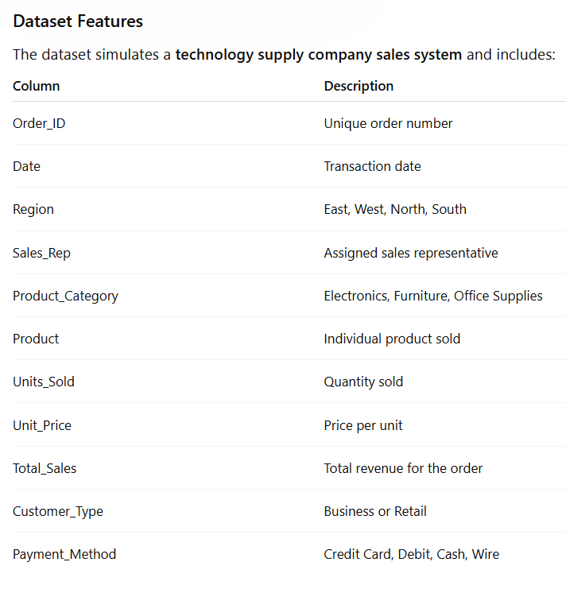

Complete the following 5 tasks.
REGIONAL PERFORMANCE ANALYSIS
Task 1: Use filters to explore sales by region.
- Filter by Region = East
- Sort Total_Sales from Largest to Smallest
Questions:
- What is the largest sale in the East region? 52950
- Which product category appears most frequently? Electronics
- Which sales representative appears most often? Brown and Johnson
CUSTOMER BEHAVIOR ANALYSIS
Task 2: Filter by
- Customer_Type = Business
Questions
- Which product category do business customers purchase most often? Office Supplies
- What is the largest business transaction? 63646.2
- Which sales rep handles the most business orders? Garcia and Brown
PRODUCT PERFORMANCE
Task 3: Use filters to analyze Product_Category.
Analyze each category separately:
- Electronics
- Furniture
- Office Supplies
Questions
- Which category appears to generate the highest total sales? Furniture
- Which specific product appears most frequently? Notebooks
- Which category tends to have the largest individual transactions? Office Supplies
PAYMENT PATTERN ANALYSIS
Task 4: Filter by Payment_Method
Analyze:
- Credit Card
- Debit
- Cash
- Wire
Questions
- Which payment method is used most frequently? Credit Card
- Do business customers prefer a specific payment type? Debit Card
- Which payment type is associated with larger purchases? Debit Purchases
TOP SALES REPRESENTATIVES
Task 5: Sort by:
- Sales_Rep
- Total_Sales(Largset > Smallest)
Questions
- Which sales rep appears to handle high-value transactions? Garcia
- Which rep appears most frequently in the dataset? Brown
- Which region do they appear to sell in most often? East
ANALYST RECOMMENDATION
Imagine you are presenting your findings to management.
Answer the following:
- Which region appears to be the strongest market? South has the strongest market with least amount of transactions.
- Which product category should the company promote more?
Electronics
- Are business customers or retail customers more valuable?
Retail as they produced a larger number of total sales.
- What two recommendations would you give the sales manager?
West and North regions could use more out reach as those are the weakest ones with less total sales

Bonus
Build
- Bar Chart – Sales by Product Category
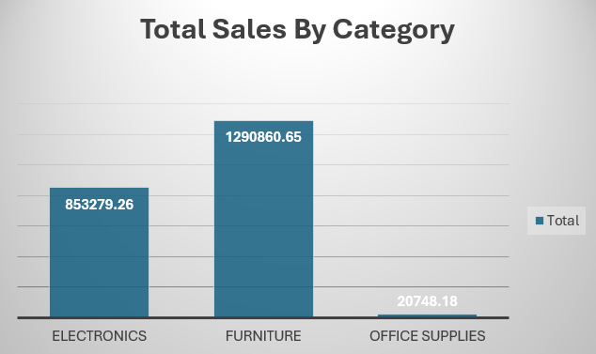
- Pie Chart – Customer Type Distribution
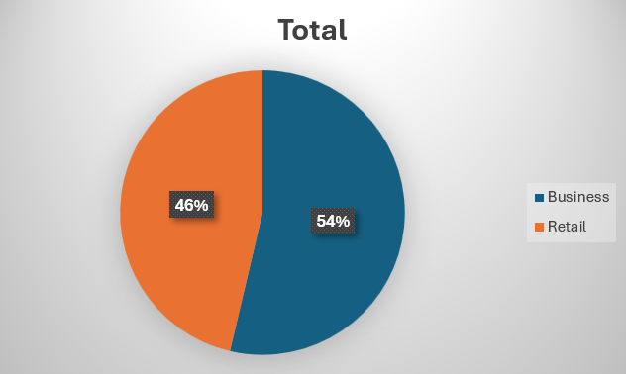
- Column Chart – Sales by Region
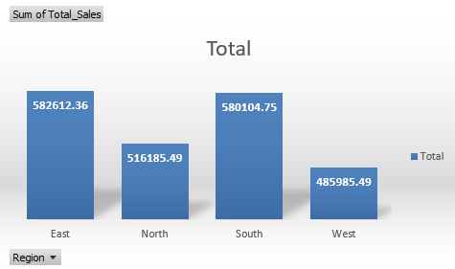
What story does the data tell?
It tells us that Business makes up a large portion of our orders but is not leading in total sales. Ou most popular items are office supplies, but they do not have high returns. North and West have lower total sales thus they are areas you can improv eon.

